**Open For Business Decorative Mirror**

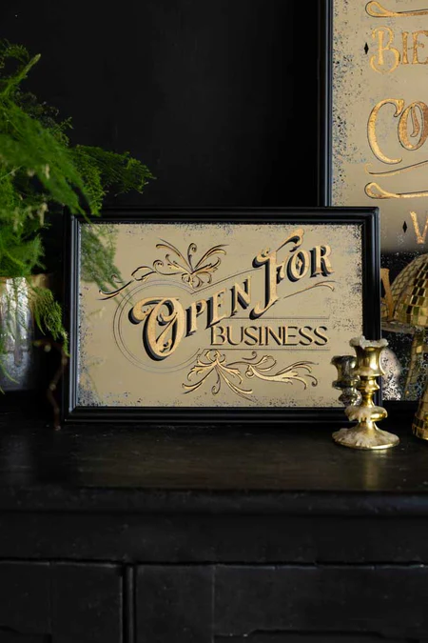The "Open For Business" Decorative Mirror is a vibrant and fun piece that combines modern design with a touch of retro charm. With bold, eye-catching typography that reads "Open For Business," this mirror serves as both a functional accessory and a striking decorative accent. Perfect for home offices, cafes, or retail spaces, the mirror’s playful design invites warmth and energy into any environment. The clean, crisp frame complements its bold message, making it an ideal piece to create a welcoming atmosphere. This mirror not only enhances the space with its reflection but also adds a quirky, inviting touch to any room.